The Rabbit Room, February 15, 2022
Lessons in Longing: A Review of Blue Flower by The Gray Havens

In his autobiography Surprised by Joy, C. S. Lewis writes of the distant Castlereagh Hills outside his nursery windows. “They were not very far off but they were, to children, quite unattainable. They taught me longing-Sehnsucht; made me for good or ill, and before I was six years old, a votary of the Blue Flower.”

The Gray Havens have always had a tinge of mystery (and more than a tinge of the Inklings) in their music. They’re a great example of the ways that music, when written well, can mine deep stores of wisdom and theology without becoming stuffy or off-putting. And my goodness, the Gray Havens’ music is written well!

Lewis’s quote, which provides the name of the band’s latest album, gives words to the great paradox that there is in us a singular desire that no experience in the world can satisfy. The word “supernatural” is so overused we forget the meaning. Think of the visible spectrum—all the light we can see—with red on one end and violet on the other. Just past the ends, invisible, there is infrared and ultraviolet. Maybe “ultranatural” is a better word than supernatural to describe this liminal space where we step outside what we know and see and realize there is something else, something beautiful and mysterious. Blue Flower, the band’s fifth studio release, dances in that space and (like another of Lewis’s works) ushers the listener from a long, drab winter to a bright and tantalizing summer.
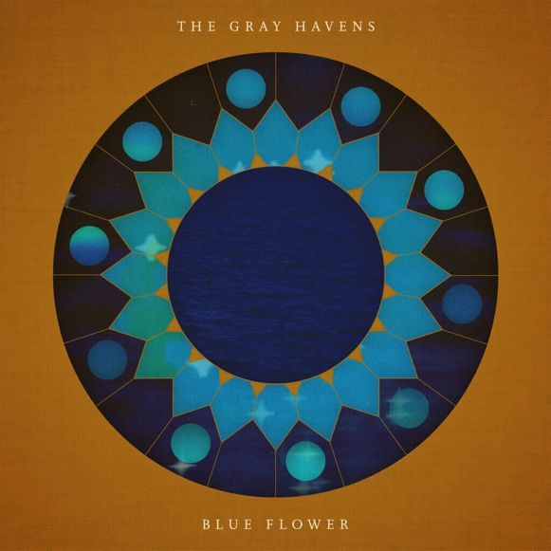
Lewis’s autobiography is filled with obscure references, and he often does not explain them. Indeed, his flower means more than we might first think, as it was an important symbol in Romanticism. Early German Romantic poet Novalis introduced the symbol in a fragmentary novel in which the protagonist, upon hearing a stranger’s stories, shares, “The Blue Flower is what I long to behold. It lies incessantly in my heart… In the world I used to live in, who troubled himself about flowers?” In 1839, Thomas Carlyle wrote an essay on Novalis, and gave this interpretation: “The ‘Blue Flower’ there spoken of being Poetry.” H. H. Boyesen expanded the thought and wrote that the flower “is meant to symbolize the deep and sacred longings of a poet’s soul. Romantic poetry invariably deals with longing; not a definite, formulated desire for some obtainable object, but a dim, mysterious aspiration, a trembling unrest, a vague sense of kinship with the infinite.” All of these meanings suggest a transcendent beauty: the feelings a poem or a song can stir that ordinary prose cannot. And long before he had knowledge of Romantic symbols, Lewis felt it. We all do. But what a challenge to capture such a mysterious and wonderful thing! That’s where the Gray Havens have triumphed. Blue Flower gives voice to sehnsucht in ways that discourses on literature just can’t. In these songs, we don’t just understand the longing, we feel it too, and we’re given space to name it, and to lament its distance even while we joy in its very existence.

Just over a minute into the opening title track, the somber, atmospheric music changes to a vibrant, lively instrumental line that swells in layer upon layer. It makes me smile every time I hear it. The music steps us out of our everyday existence into some other alluring realm, and like six-year-old Lewis, the listener knows there is something more.

Ben Shive’s production employs a broad range of instrumentation to set a cinematic place for each song. The album’s themes are as strong in the music as in the lyrics. Shive is a master at strings, and his touch here is perfect. Havens’ founder Dave Radford was more involved in the production for this album, and the collaboration is wonderful. The toolbox was wide open—percussion, horns, loops—but the tools are used with expert precision, and always in service of the theme. In these songs, we don’t just understand the longing, we feel it too, and we’re given space to name it, and to lament its distance even while we joy in its very existence.

I’ve listened to this album for a while now, but only recently have I done so through a critic’s lens, and I’ve realized something: pulling this off was so difficult! Think about the task: write about this soul-deep, inconsolable longing we all feel but can’t always describe. Go ahead and describe it. Then, actually stir that thing in our souls. Consider how adeptly these songs accomplish all of this. “Rhythm of the East” hints at something otherworldly, in staccato lyrics and music, acknowledges how difficult it is to share, and points to the source in the rising sun and its Creator. “I remember now in December how, like a split-second dream, I heard a summer song; if I get it wrong, you can find it in the east.” How clever for a song to describe an attempt to remember a song. “Wide Awake” is somehow musically sparse and full at the same time, capturing two planes of existence and inviting us to tune our senses to the one we can’t always see. The lyric acknowledges how we as adults might try to talk ourselves out of the possibility of this land we imagined as a child where the blue flowers grow. Albums like this could steer off a ledge into ethereal or academic pitfalls, but choruses like this one make Blue Flower into something honest and accessible.
The Gray Havens grow with each new album, and it’s a delight to enjoy. Radford’s songwriting has always been impressive, but here he’s accomplished something remarkable: an album about transcendence that is, itself, transcendent.
Click here to listen to Blue Flower on Spotify and here to listen on Apple Music.

